**ASSIGNMENT 4**

|  |  |
| --- | --- |
| Date | 02 Nov 22 |
| Name | R.RANJINI |
| Team Id | PNTIBMWb72 |
| Assignment | Four |

Write code and connections in wokwi for ultrasonic sensor.

* Whenever distance is less than 100 cms send "alert" to ibm cloud and display in device recent events.

Upload document with wokwi share link and images of ibm cloud

**CODE:**

|  |
| --- |
| #include <WiFi.h>  #include <PubSubClient.h> WiFiClient wifiClient;    #define ORG "nhpwjc"  #define DEVICE_TYPE "NodeMCU"  #define DEVICE_ID "USE YOUR ID"  #define TOKEN "USE YOUR TOKEN"  #define speed 0.034 char server[] =  ORG  ".messaging.internetofthings.ibmcloud.com"; char publishTopic[]  = "iot-2/evt/Data/fmt/json"; char topic[] = "iot-  2/cmd/home/fmt/String"; char authMethod[] = "use-tokenauth"; char token[] = TOKEN;  char clientId[] = "d:" ORG ":" DEVICE_TYPE ":" DEVICE_ID;  PubSubClient client(server, 1883, wifiClient); void publishData(); const int trigpin=5;  const int echopin=18;  String command;  String data=""; long  duration; float dist;    void  setup()  {  **Serial**.begin(115200); pinMode(trigpin, OUTPUT); |

|  |
| --- |
| pinMode(echopin, INPUT); wifiConnect(); mqttConnect();  } void loop() { publishData(); delay(500);  if (!client.loop()) { mqttConnect(); }  }  void wifiConnect() {  **Serial**.print("Connecting to "); **Serial**.print("Wifi");  WiFi.begin("Wokwi-GUEST", "", 6); while (WiFi.status() !=  WL_CONNECTED) { delay(500); **Serial**.print("."); }  **Serial**.print("WiFi connected, IP address: "); **Serial**.println(WiFi.localIP());  }  void mqttConnect() { if  (!client.connected()) {  **Serial**.print("Reconnecting MQTT client to "); **Serial**.println(server); while  (!client.connect(clientId, authMethod, token)) { **Serial**.print("."); delay(500); } initManagedDevice(); **Serial**.println(); } }  void initManagedDevice() { if  (client.subscribe(topic)) {  // Serial.println(client.subscribe(topic)); **Serial**.println("subscribe to cmd OK");  } else {  **Serial**.println("subscribe to cmd FAILED"); } } void publishData()  { digitalWrite(trigpin,LOW); digitalWrite(trigpin,HIGH); |
| delayMicroseconds(10); digitalWrite(trigpin,LOW); duration=pulseIn(echopin,HIGH); dist=duration*speed/2; if(dist<100){ String payload = "{\"Alert distance\":"; payload += dist; payload += "}";  **Serial**.print("\n");  **Serial**.print("Sending payload: "); **Serial**.println(payload); if (client.publish(publishTopic, (char*) payload.c_str())) { **Serial**.println("Publish OK");  } else {  **Serial**.println("Publish FAILED"); }  }  } |

**CONNECTIONS:**

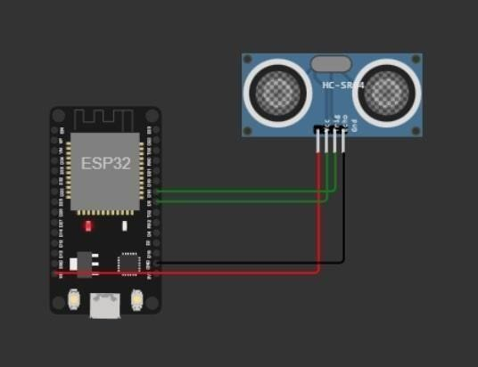

**OUTPUT:**

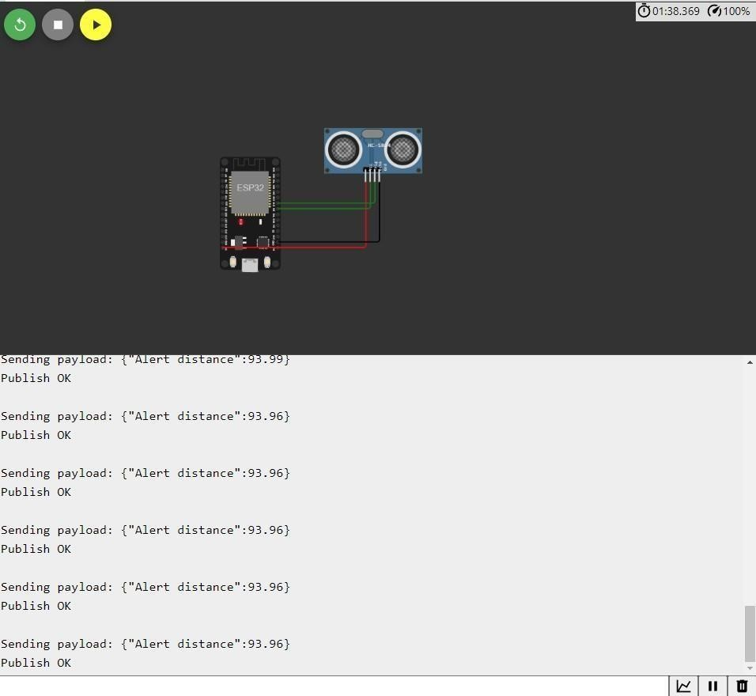

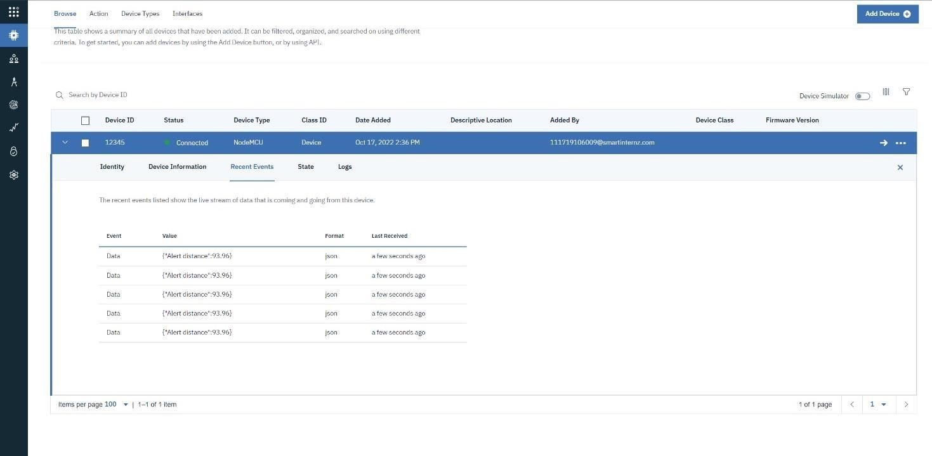

**WOKWI LINK -**

[**https://wokwi.com/projects/346405970317935188**](https://wokwi.com/projects/346405970317935188)